**HADOOP**

1. **Data Ingestion:**

* Create a directory in HDFS and transfer the banking dataset from the local system to the HDFS directory.

Procedure: Establishing Access to the Hadoop Environment

1. Hadoop Environment Configuration

The Hadoop environment was configured using two principal methods:

Implementation of Hadoop on a local system

Deployment of a Docker-based, containerized Hadoop environment

1.1 Local Hadoop Environment Setup

Step 1: Open a terminal session on the machine with the Hadoop installation, or navigate to the Hadoop binary directory via command-line interface.

Step 2: For Hadoop installations on Windows, initiate all essential Hadoop services—including the NameNode, DataNode, ResourceManager, and NodeManager—by executing the start-all.cmd script. Alternatively, it is possible to start individual YARN daemons by using start-dfs.cmd and start-yarn.cmd commands.

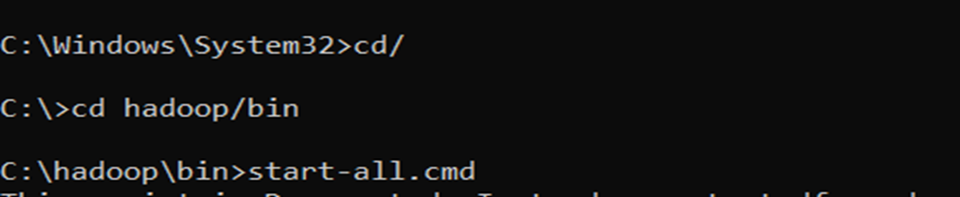

1.2 HDFS Directory Creation

A new directory within the Hadoop Distributed File System (HDFS) can be established by executing the command:

hadoop fs -mkdir <directory_name>



1.3 Migration of Banking Dataset to HDFS

Transfer the bank.csv dataset from the local file system to the newly created HDFS directory by using:

hadoop fs -copyFromLocal bank.csv <hdfs_directory>



1.4 Data Verification

To verify that the data has been correctly loaded into the specified directory, access the Hadoop web interface via a web browser at localhost:50070 for data visualization.

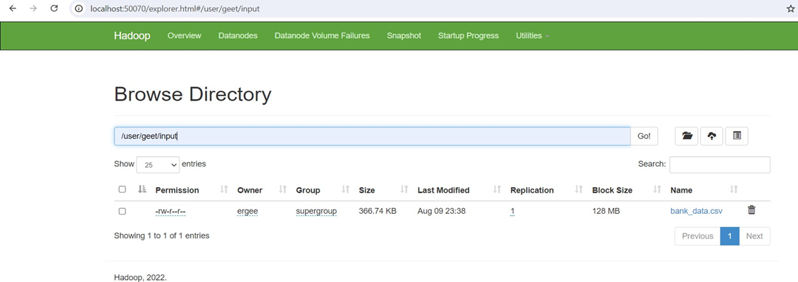

2. Containerized Hadoop Implementation with Docker

The following steps outline the creation of an HDFS directory and the migration of the banking dataset into HDFS using a Hadoop Docker container:

2.1 Docker-Based Hadoop Configuration

Step 1: Utilize an open-source Hadoop framework repository (available on GitHub) to implement the setup.

Step 2: Navigate to the directory containing the Docker configuration file, then initialize the Hadoop cluster in detached mode (background) with:

docker-compose up -d

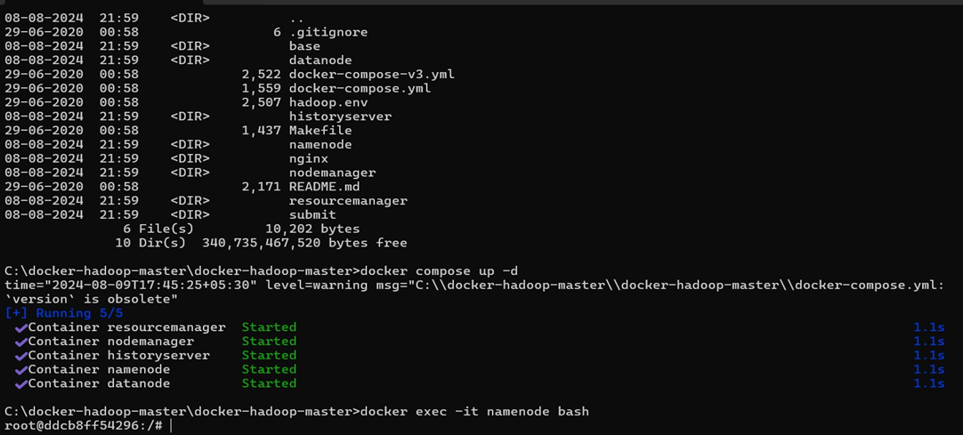

2.2 Container Shell Access

Gain access to the active NameNode container shell by executing:

docker exec -it namenode bash

2.3 Directory Establishment in HDFS

Inside the NameNode container, establish a new directory within HDFS by running:

hadoop fs -mkdir <directory_name>

2.4 Migration of Banking Dataset from Local System to HDFS



Step 1: Transfer the bank.csv file from the local machine to the temporary storage within the Docker container with:

docker cp bank.csv namenode:/tmp

Step 2: Move the file from temporary storage to the HDFS input directory using:

hdfs dfs -put /tmp/bank.csv <hdfs_directory>

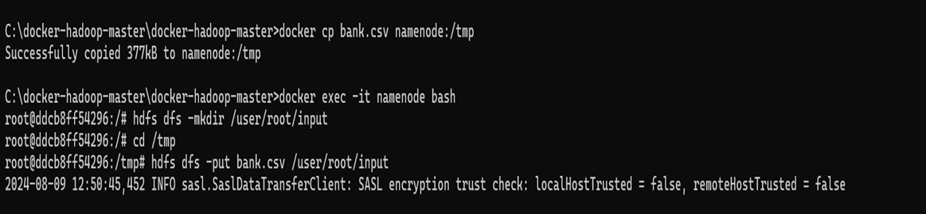

2.5 Data Loading Verification

Confirm successful data transfer to the appropriate HDFS directory by accessing the Hadoop web interface at localhost:9870 through a web browser for visualization and verification.

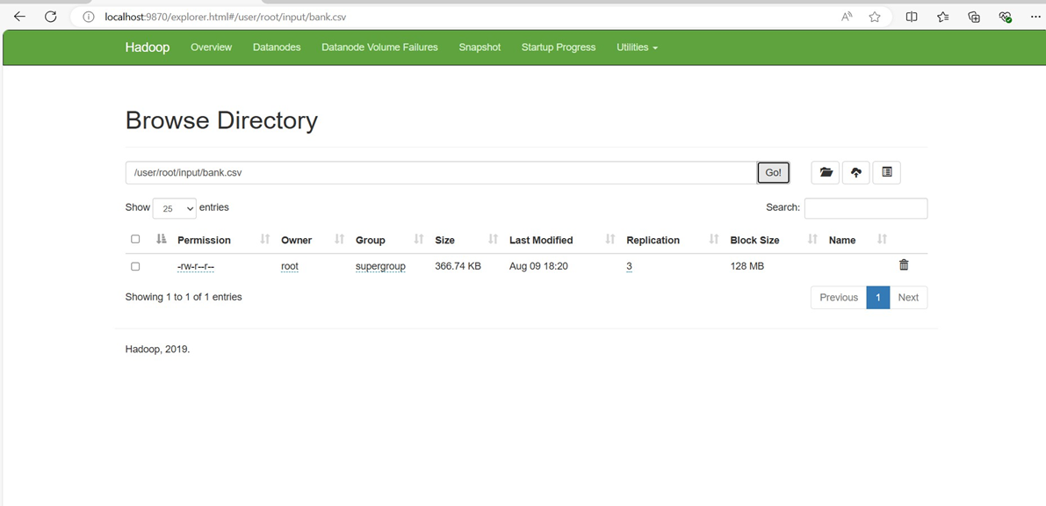

1. **Data Transformation with MapReduce:**

* Write a MapReduce program in Python that calculates the average account balance for each job type.

Step 1: Develop the MapReduce Python Scripts

Compose the necessary MapReduce scripts and save them as Mapper.py and Reducer.py.

Note: The above-mentioned code files (Mapper.py and Reducer.py) have been provided separately alongside this document.

Step 2: Prepare HDFS for Data Processing

Create a new directory within the Hadoop Distributed File System (HDFS) and upload the banking dataset bank_data.csv from your local machine to this directory.

Step 3: Execute the MapReduce Job

Initiate your MapReduce job by specifying the relevant input and output paths in your command.

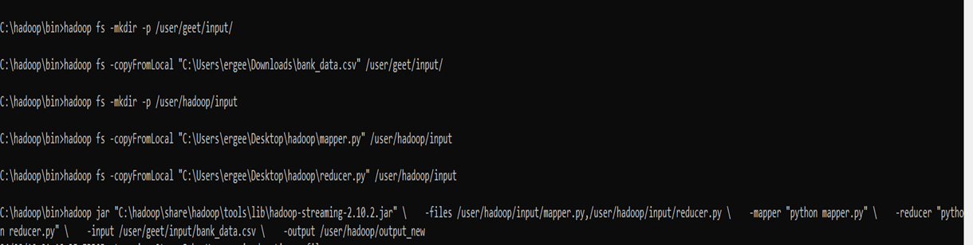

Step 4: Retrieve and Visualize Results

After the MapReduce job has completed, access and visualize the results by running the following command:

Use hadoop fs -cat /user/hadoop/output_new/part-00000

This command will display and retrieve the output directly from the specified output directory.

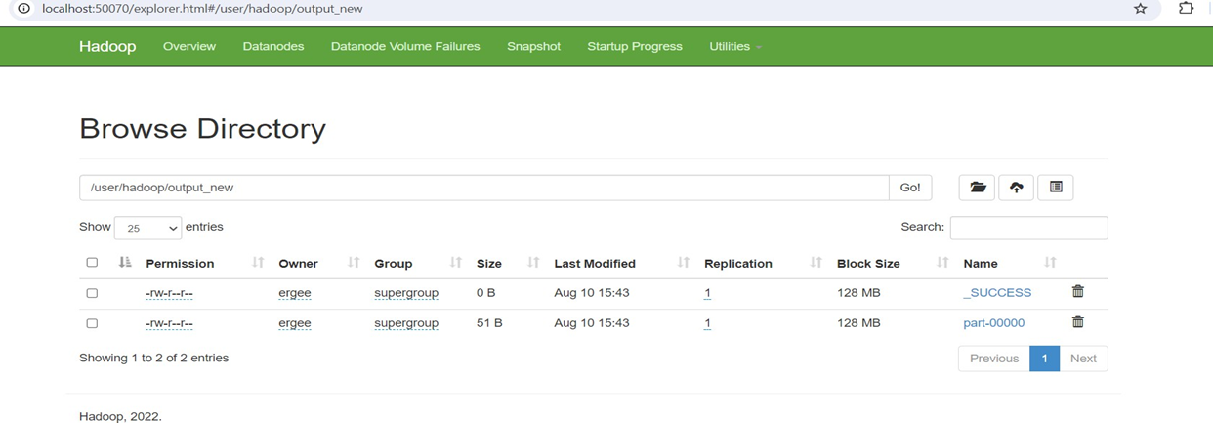

Output:

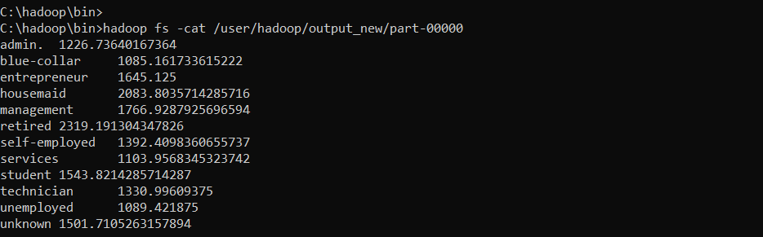

* Write another MapReduce program that counts the number of individuals with and without a housing loan in each education category.

Step 1: Develop MapReduce Python Scripts

Create the MapReduce scripts required for processing and save them as Mapper.py and Reducer.py.

Note: These two code files have been submitted as separate files accompanying this document.

Step 2: Execute the MapReduce Job

Initiate your MapReduce job by specifying the appropriate input and output paths in your command.

Note: It is considered best practice to remove any existing output directory before executing a new MapReduce job in Hadoop, in order to prevent potential overwriting errors.

To delete the output directory, use the following command:



hadoop fs -rm -r <output_directory>

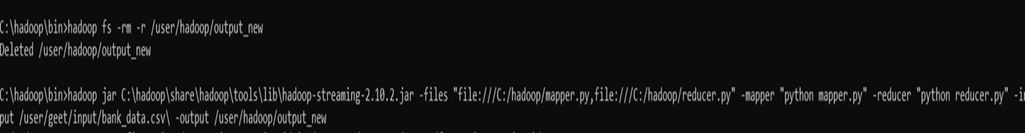

Output:

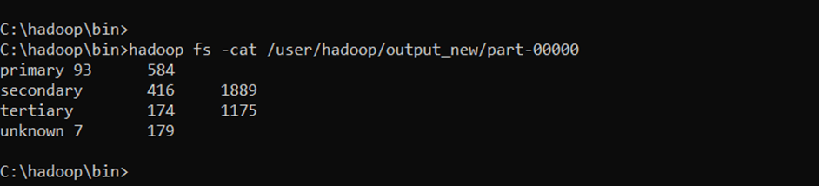

* Perform a MapReduce job to determine the number of clients contacted in each month and their subscription status to term deposits ('y' column).

Step 1: Remove the Output Directory Prior to Execution

Before initiating a new MapReduce job, ensure the output directory is deleted to prevent conflicts and overwriting issues.

Step 2: Develop the MapReduce Python Scripts

Write the required MapReduce scripts and save them as Mapper.py and Reducer.py.

Note: The Mapper.py and Reducer.py files have been provided separately along with this document.

Step 3: Execute the MapReduce Job

Run your MapReduce job by specifying the appropriate input and output directory paths.

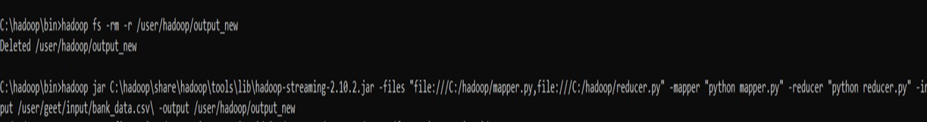

Output:

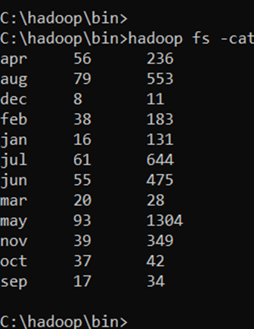

1. **Data Analysis with MapReduce:**

* Analyze the average duration of contact (in seconds) per campaign outcome ('poutcome').

Procedure:

Develop the MapReduce Scripts

Compose the required MapReduce scripts and save them as mapper.py and reducer.py.

Note: These script files (mapper.py and reducer.py) are provided separately in addition to this document.

Upload Banking Data to HDFS

Transfer the banking dataset to the Hadoop Distributed File System (HDFS) to facilitate distributed processing.

Execute the MapReduce Job on the Hadoop Cluster

Run the MapReduce job, specifying the correct input and output directories on your Hadoop cluster.

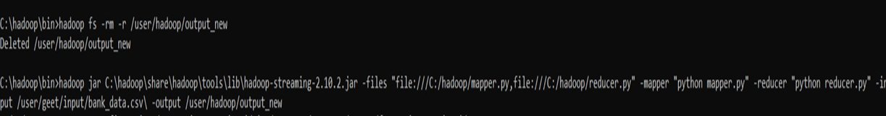

Review and Interpret Results

Upon completion of the MapReduce job, examine and interpret the output data accordingly.

Clean Up Output Directory for Subsequent Runs

If it becomes necessary to rerun the job, ensure the output directory is cleared to prevent Hadoop overwriting errors.

Output:

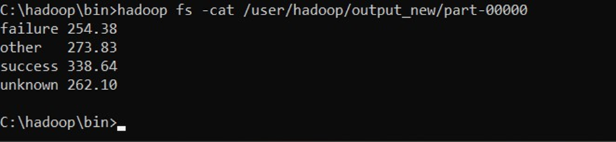

Summary:

The executed MapReduce job processed the dataset to compute the average contact duration (in seconds) for each campaign outcome. The observed results are summarized below:

Failure: Average contact duration of 254.38 seconds

Other: Average contact duration of 273.83 seconds

Success: Average contact duration of 338.64 seconds

Unknown: Average contact duration of 262.10 seconds

These results indicate that campaign outcomes classified as success demonstrated the highest average contact duration, whereas failed outcomes were associated with the shortest contact durations.

* Examine the relationship between the age of clients and their balance, and present findings in a summarized form.

Purpose

This analysis investigates the variation in account balance for each specific age group. Rather than aggregating ages into bins, it provides a direct average balance for every individual age, thereby offering a finer and more detailed perspective on the relationship between age and account balance.

Implementation

A MapReduce job is employed for this task. The mapper script outputs the age and balance for each client, while the reducer script computes the average balance for each unique age present in the dataset.

Results

The output reveals the average account balance associated with each specific age, delivering granular insight into age-specific financial behaviour.

Steps:

Develop MapReduce Scripts

Construct the required MapReduce scripts and save them as mapper.py and reducer.py.

Note: These two code files have been submitted with the document as separate files.

Upload the Banking Data to HDFS

Transfer the banking dataset to the Hadoop Distributed File System (HDFS).



Execute the MapReduce Job

Launch the MapReduce job on your Hadoop cluster, specifying the appropriate input and output directories.

Interpret the Results

Review the output to obtain and interpret average balances associated with each age.

Clean Up for Subsequent Runs

If you need to rerun the job, ensure the output directory is deleted to avoid errors.

Output:

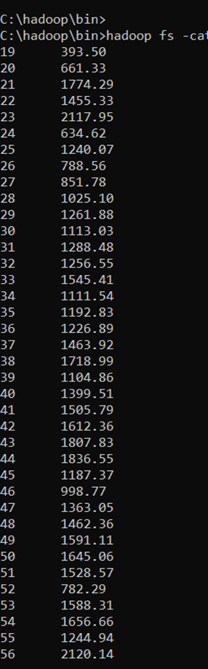 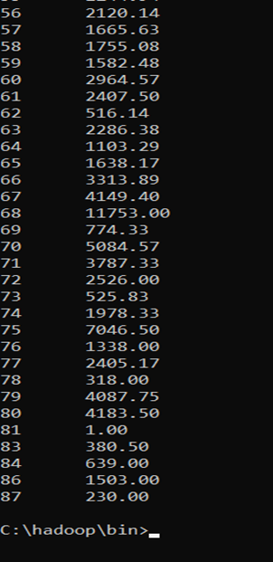

Summary of Findings:

Upon completion of the MapReduce job, the results provide the average account balance corresponding to each individual age.

Key observations include:

Age-Specific Averages: Each age is represented with its respective average balance. For example, individuals aged 23 may have an average balance of 2,117.95, while those aged 25 may have an average of 1,240.05.

Trends: There may be discernible trends in the data:

Increase with Age: In certain cases, a gradual rise in average balance as age increases may be evident.

Fluctuations: Some ages might display noticeably higher or lower balances due to particular financial behaviours or significant life events.

Variability: The average balances are likely to exhibit substantial fluctuations across various ages, highlighting the diverse economic situations encountered throughout different life stages.

Conclusion:

The analysis successfully uncovers the average balance for each individual age, facilitating the detection of patterns and outliers in financial behaviour across the age spectrum. Such granular information is instrumental for financial institutions in tailoring products and services to better meet the needs of diverse age groups.

**HIVE**

1. **Data Ingestion and Table Creation**:
   * Create a Hive database named **banking_data**.

Steps to Create a Hive Database:

Start the Hive Command Line Interface (CLI)

Begin by launching the Hive CLI on your system.

Create a New Database

Execute the following command to create a new database named banking_data:

CREATE DATABASE banking_data;

Switch to the Newly Created Database

Set the current working database to banking_data by executing:

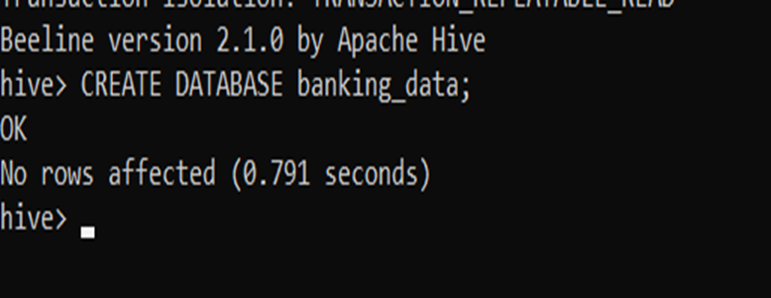

USE banking_data;



* + Define and create a Hive table **client_info** with appropriate data types for the **bank.csv** dataset.

● Create the client_info table with appropriate data types based on the columns in the bank.csv file:

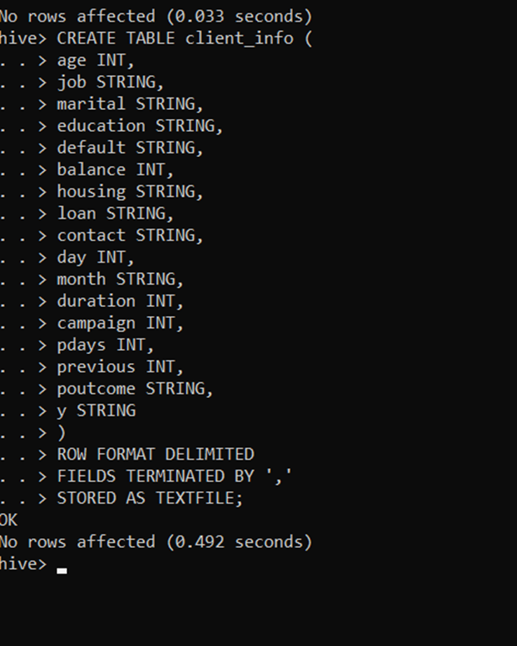

* + Load the data from the **bank.csv** file into the **client_info** table.

1. Load the Banking Data into the client_info Table

Execute the following command in Hive to load the CSV data from the Hadoop directory (adjust the HDFS file path as needed):

LOAD DATA INPATH '/user/hadoop/bank.csv' INTO TABLE client_info;

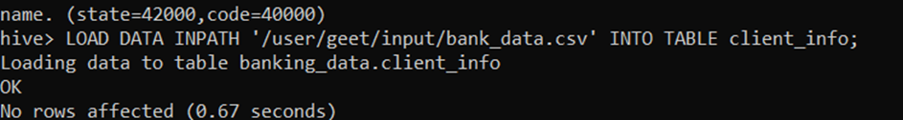

2. Verify Data Load by Querying the Table

To confirm that the data has been loaded correctly, retrieve a sample of the records:

SELECT * FROM client_info LIMIT 10;

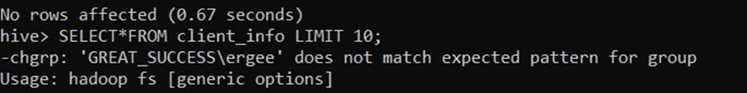

Output:

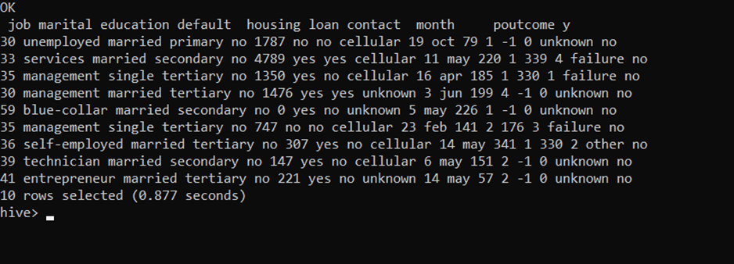

If the output displays the first ten rows from your dataset, it indicates that the data has been successfully loaded into the client_info table.

1. **Basic Data Exploration**:
   * Write a HiveQL query to count the total number of clients in the dataset.

Steps:

1. FROM client_info: This query retrieves data from the client_info table, which contains the records of all clients.

2. COUNT() AS total_clients: The COUNT() function is used to calculate the total number of rows within the client_info table. The resulting value is labeled as total_clients to enhance clarity.

Query:

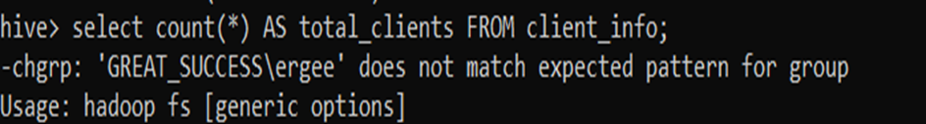

Output:

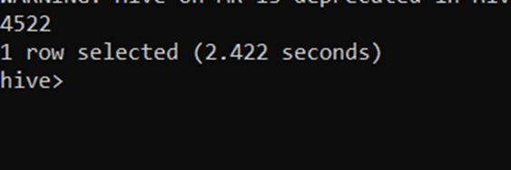

Summary of the Results:

- Total Number of Clients: The query produces a single value that represents the total number of clients in the dataset. This figure provides a concise overview of the dataset’s size, indicating the number of client records available for analysis. In this instance, the total number of clients is 4522.

* + Display the first 10 rows of the dataset.

Steps:

FROM client_info:

The query retrieves data from the client_info table, which contains all the records in the dataset.

SELECT :

The query selects all columns () from the client_info table. This ensures that every piece of information available for each client is included in the result.

LIMIT 10:

The query limits the output to only the first 10 rows of the dataset. This approach is useful for quickly examining a sample of the data without having to retrieve the entire dataset.

Query:

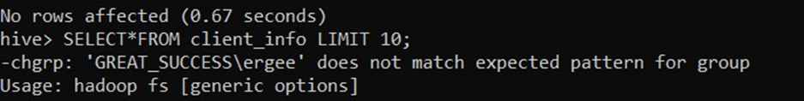

Output:

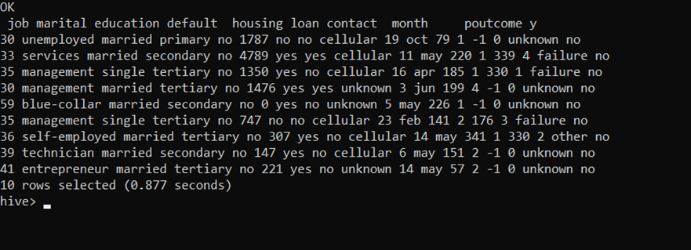

Summary of the Results:

First 10 Rows of the Dataset:

The output displays all columns and their values for the first 10 clients from the client info table. These rows provide a brief snapshot of the overall dataset, illustrating both its structure and contents.

1. **Data Filtering and Sorting**:
   * Retrieve all records of clients who are married and have a personal loan.

Steps:

FROM client_info:

The query extracts data from the client_info table, which contains various client details, such as marital status, loan status, and other relevant attributes.

SELECT :

The query selects all columns () from the client_info table. As a result, all available information for each client, including age, job, balance, and more, will be included in the returned output.

WHERE marital = 'married' AND loan = 'yes':

The query applies filters to select only those clients who satisfy both of the following conditions:

marital = 'married': The client is married.

loan = 'yes': The client has a personal loan.

Query:

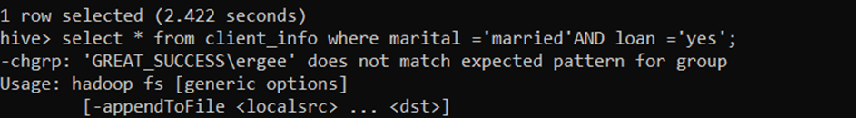

Output:

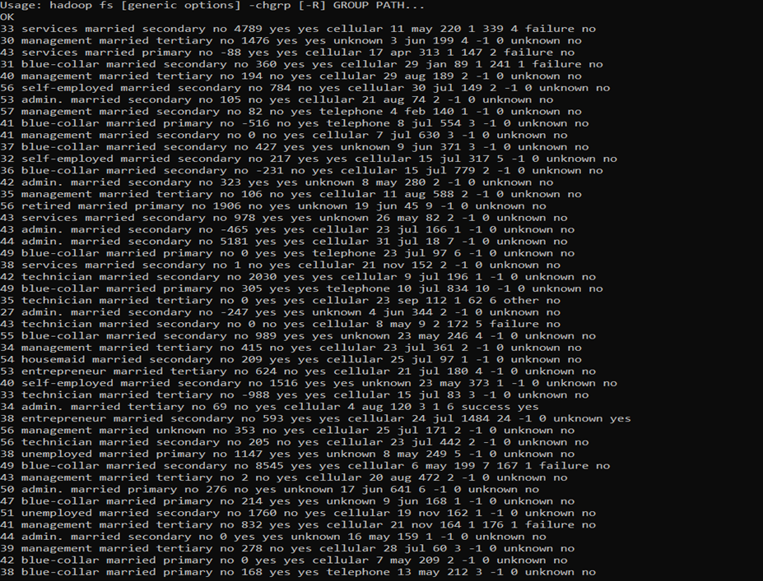

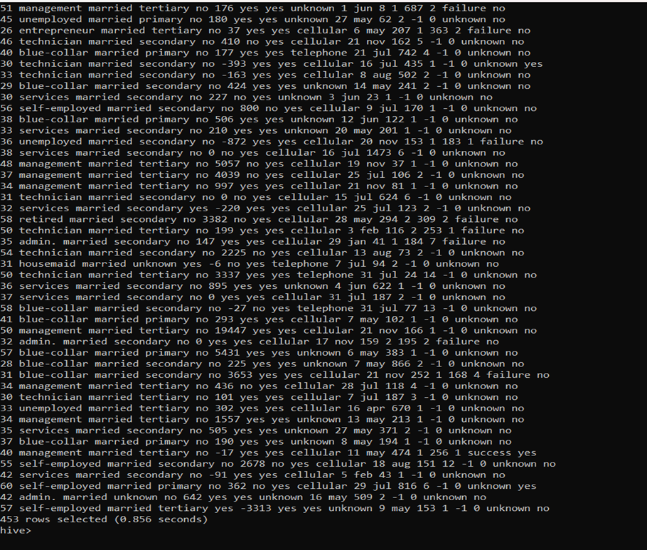

Summary of the Result:

This query refines the dataset to display records only for clients who are both married and have taken a personal loan.

The resulting output consists of all columns for these filtered clients, providing full details for each qualifying record.

* + List the top 10 clients with the highest balance, displaying their job, marital status, and balance.

Steps Involved:

Extracting from client_info:

The data is sourced from the client_info table, which holds essential details about each client, including variables such as their profession, marital status, and account balance.

Choosing Columns:

Only the job, marital, and balance fields are selected. This narrows the focus to just these three attributes for every client.

Sorting by Highest Balance:

Results are organized such that clients with the largest balances appear at the top of the list, using a descending sort order on the balance column.

Displaying a Sample:

The output is limited to just ten entries, highlighting only the top 10 clients with the most substantial balances.

Query:



Result:

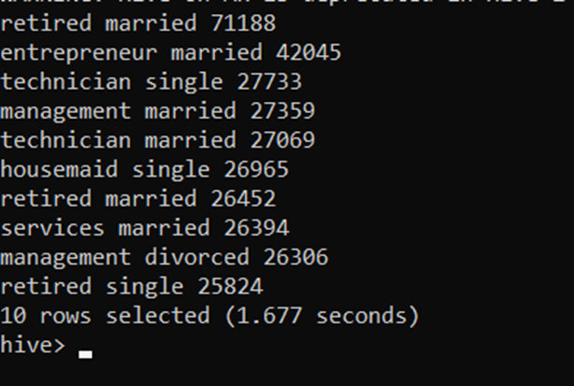

Result Overview:

Top Clients by Account Balance:

The outcome reveals the profession, marital status, and balance of the ten clients holding the highest account balances. Interestingly, many of these top clients are retired and married, reflecting a pattern in the dataset.

1. **Data Aggregation and Grouping**:
   * Calculate the average age of clients for each job category.

Process Description:

The query works on the client_info table, which maintains data such as each client’s occupation and age.

Grouping by job:

Data is organized into groups based on the job column, so that each profession is processed separately.

Calculating average age:

The script computes the mean age of clients in every profession using the AVG(age) aggregate function, assigning the result to a new column called average_age.

Selecting results:

In the final step, the output displays both the profession (job) and the corresponding average client age (average_age) for every job group.

Query:



Result:

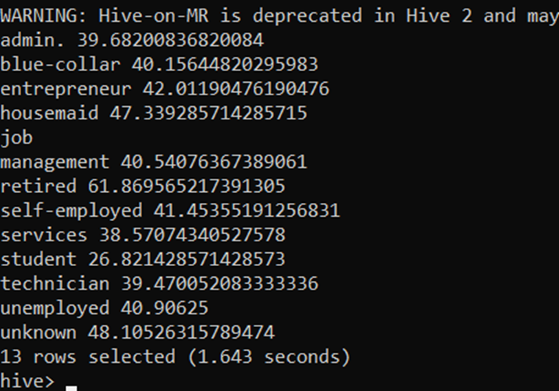

Summary of the Results:

Average Age Categorized by Profession:

The result reveals the average age for clients within each occupational group, offering a snapshot of age distribution across various job categories. The analysis shows that, for most professions, client average ages generally fall between 35 and 45 years.

* + Find the total number of clients for each education level who have defaulted on credit.

Process Explanation:

Data Source:

The operation begins by referencing the client_info table, which contains key information such as the client’s education background and credit default status.

Applying a Filter:

The filter condition (WHERE default = 'yes') ensures that only those clients who have actually defaulted on credit are included in the analysis.

Grouping Data:

The next step groups these filtered records according to both education level and default status, using the education and default columns.

Counting Defaults:

For each group, the query determines how many clients have defaulted by applying the COUNT(*) function. This result is labeled as total_defaulted_clients.

Final Output:

The selected view includes the client’s education level, their default status, and the count of defaults within each education group.

Query:

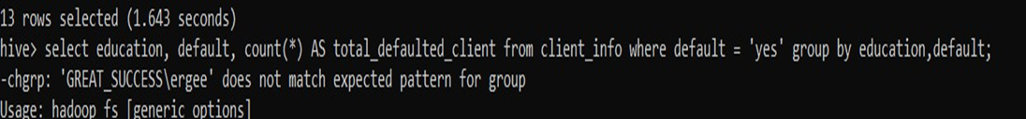

Output:

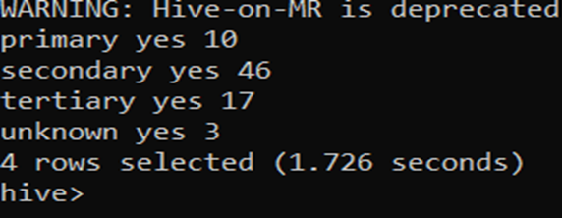

Summary of Result:

Defaults by Education Level:

The output reveals the number of clients who have defaulted on credit across different education levels. It is evident that most defaults are observed among clients with a secondary education background.

1. **Complex Queries for Insights**:
   * Identify the top 5 job categories with the highest average balance and the percentage of clients in each of these job categories who have subscribed to a term deposit.

Step 1: Inner Query – Identifying Top 5 Job Categories by Average Balance

The data is sourced from the client_info table.

Results are grouped using the job column, so each job type is considered separately.

The average account balance is calculated for every job category (AVG(balance)), labeled as avg_balance.

The total number of clients per job group is counted (COUNT(*)), saved as total_clients.

Subscribed clients are tallied using SUM(CASE WHEN y = 'yes' THEN 1 ELSE 0 END), counting only those who subscribed to the term deposit as subscribed_clients.

The job groups are sorted in descending order according to their average balance (ORDER BY avg_balance DESC).

Only the five job categories with the highest average balances are retained (LIMIT 5).

Step 2: Outer Query – Calculating Subscription Percentage

The outer query selects data from the inner query (aliased as sc).

It retrieves the job and avg_balance fields from the inner results.

Subscription percentage is calculated as (sc.subscribed_clients / sc.total_clients) * 100, with the result stored as subscription_percentage.

Query:

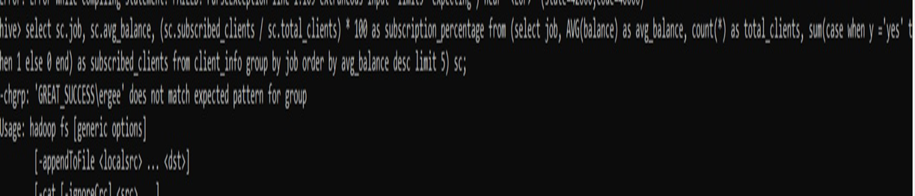

Output:

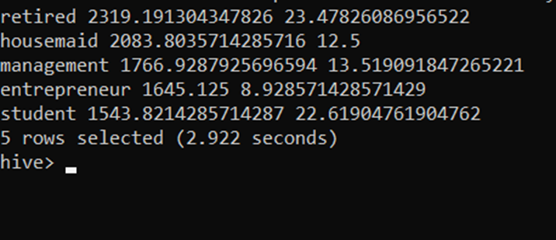

Summary of the Results:

Top 5 Job Categories by Average Balance:

The query highlights which job types have the highest average account balances, with categories like retired and housemaid often ranking at the top.

Subscription Percentage:

It measures how effective the term deposit campaign was for these high-balance categories. Subscription_percentage reflects the proportion of subscribers in each group. For instance, the conversion rate was not high among entrepreneurs, with a subscription rate of only 8.93 percent.

* + Determine the month with the highest number of contacts and the success rate of the campaign in that month (percentage of clients who subscribed to a term deposit).

Steps:

Inner query:

Data is selected from the client_info table.

Records are grouped by the month column, enabling monthly analysis.

The total number of records (contacts) is counted for each month with COUNT(*), saved as total_contacts.

Successful contacts per month are counted using SUM(CASE WHEN y = 'yes' THEN 1 ELSE 0 END), representing the number of clients who subscribed to a term deposit; this is stored as successful_contacts.

Results are sorted by total_contacts in descending order, so the month with the most contacts appears first.

Only the single month with the highest contact volume is retained (LIMIT 1).

Outer Query:

The outer query uses the results of the inner query (aliased as top_month).

The fields month and total_contacts are selected directly

The success rate for that month is calculated as (successful_contacts / total_contacts) * 100, reflecting the percentage of conversions.

Query:



Output:

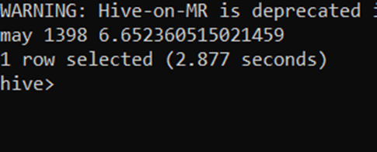

Summary:

This query identifies the month with the highest number of client contacts and determines the campaign’s success rate for that period (as a percentage of clients subscribing to a term deposit).

For example, May had the greatest number of contacts (1398) and a success rate of 6.65 percent.

1. **Correlation Analysis**:
   * Calculate the correlation between age and balance for the clients.

The CORR(age, balance) function computes the Pearson correlation coefficient between the age and balance columns in the dataset.

The coefficient takes values between -1 and 1:

1 shows a perfect positive relationship,

-1 shows a perfect negative relationship,

0 means there’s no correlation.

Query:

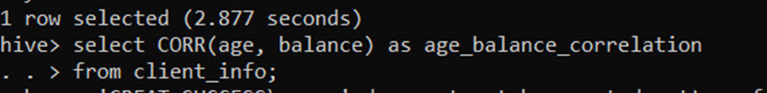

Output:

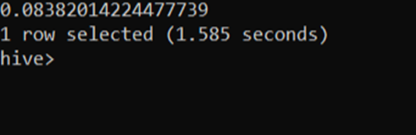

Summary Of Result:

The result indicates the degree to which age and account balance are related. Here, the correlation value is 0.0838, which falls close to zero. This suggests there is only a slight positive relationship between a client’s age and their account balance.

1. **Trend Analysis**:
   * Analyze the year-over-year trend in the number of clients contacted.

Steps:

Extract Year: The SUBSTRING(month, 1, 4) function selects the first four characters from the month column, treating them as the year portion (e.g., extracting "2023" from "2023-Jan").

Count Contacts by Year: Grouping is performed on the extracted year, and the total number of client contacts is counted for each year.

Query:

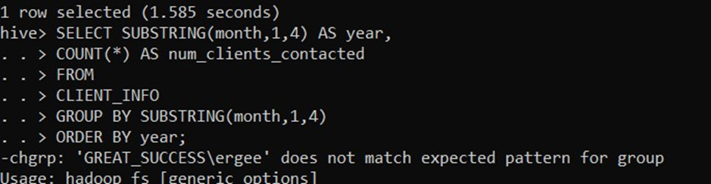

Output:

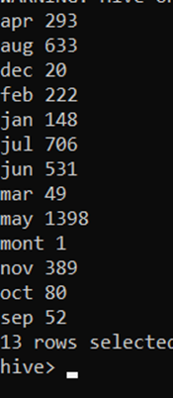

Summary of result:

This output would typically reveal how the number of client contacts changes from year to year. However, since the bank_data.csv file does not include year information in the month column, it’s not possible to generate the required year-wise trend.

1. **Anomaly Detection**:
   * Identify any unusual patterns in the average yearly balance across different education levels.

Inner Query (Subquery):

SUBSTRING(month, 1, 4) AS year: Extracts the year from the month column, assuming the month format contains the year (e.g., "2024-08").

education: Selects the education field from client_info.

AVG(balance) AS avg_yearly_balance: Calculates the average client balance for each year and education level.

AVG(AVG(balance)) OVER (PARTITION BY SUBSTRING(month, 1, 4)) AS overall_avg_balance: Determines the overall average balance for each year across all education levels using a window function.

STDDEV(AVG(balance)) OVER (PARTITION BY SUBSTRING(month, 1, 4)) AS stddev_balance: Computes the standard deviation for average balances within each year across all education levels.

GROUP BY SUBSTRING(month, 1, 4), education: Groups the metrics by both year and education level.

Outer Query:

(avg_yearly_balance - overall_avg_balance) / stddev_balance AS z_score: Calculates the z-score, which measures how much the average balance for a given year and education level deviates from the overall average balance for that year, expressed in standard deviations.

Query:

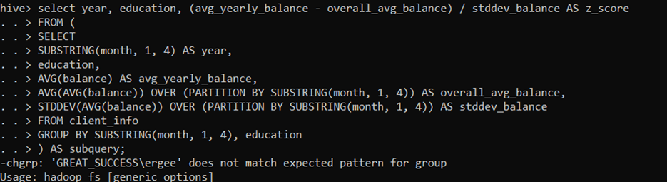

Output:

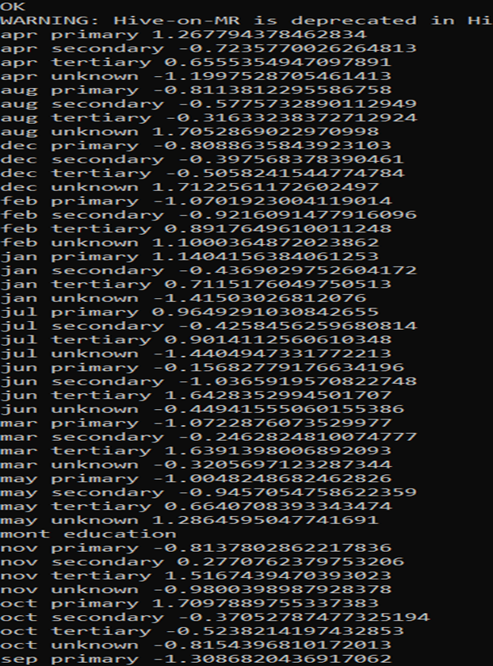

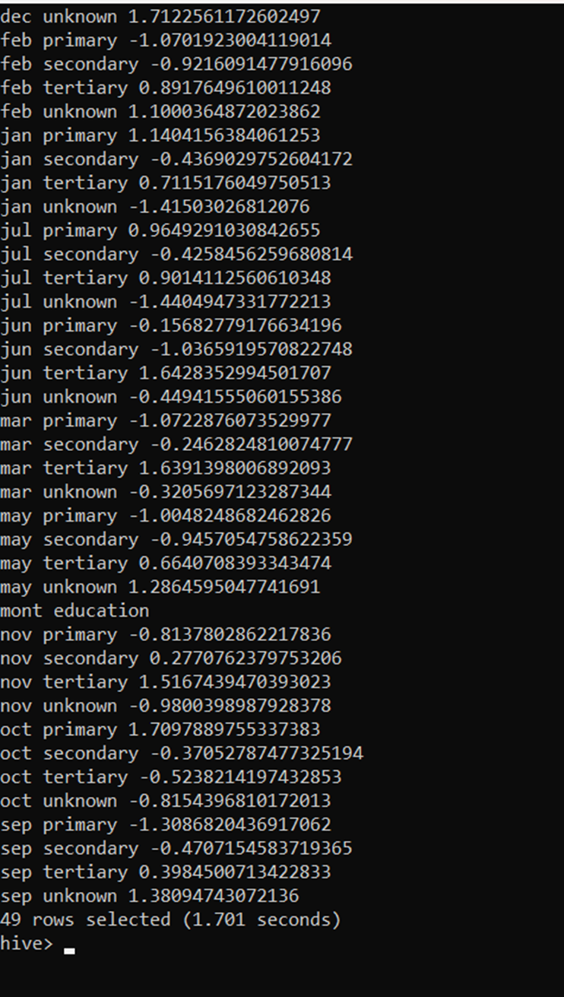

Summary of the Results:

year: The year extracted from the month column.

education: The education level for each group of clients.

z_score: Reflects how the average yearly balance for a specific education category compares to the overall annual average. A positive z-score means above-average balance, while a negative score means below-average balance for that year.

Output Interpretation:

Positive Z-Scores: Indicate the average balance for a specific education group is higher than the year’s overall average.

Negative Z-Scores: Indicate the group’s average balance is lower than the overall annual average.

1. **Advanced Analysis**:
   * Analyze the impact of previous campaign outcomes (**poutcome**) on the current campaign's success. Calculate the subscription rate (to term deposits) for each **poutcome** category.

Select Columns:

poutcome: Indicates the result of the previous marketing campaign (such as 'success', 'failure', etc.).

COUNT(*) AS total_clients: Counts the total number of clients within each poutcome category.

SUM(CASE WHEN y = 'yes' THEN 1 ELSE 0 END) AS subscribed_clients: Tallies the number of clients who subscribed to the term deposit for each outcome group.

ROUND(SUM(CASE WHEN y = 'yes' THEN 1 ELSE 0 END) * 100.0 / COUNT(*), 2) AS subscription_rate: Calculates the term deposit subscription rate for each poutcome group as a percentage, rounded to two decimal places.

From:

The data is pulled from the client_info table.

Group By:

Results are grouped by the poutcome column, so all calculations are performed separately for each outcome type.

Order By:

The results are ordered by subscription_rate in descending order, showing which previous outcomes led to the highest subscription rates.

Query:

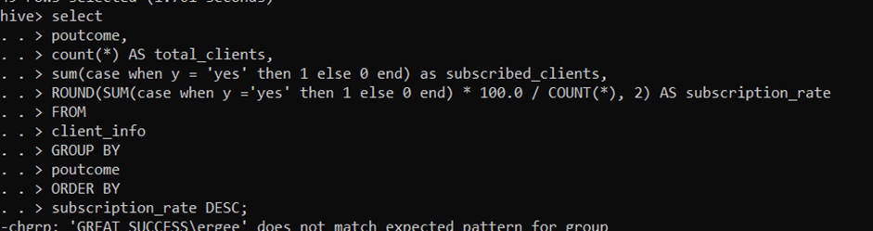

Result:

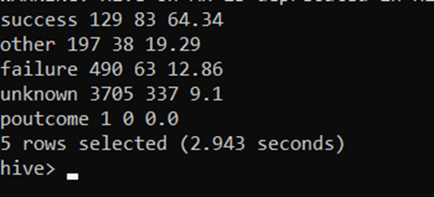

Summary of the Results:

poutcome: Shows the outcome category of clients from the previous marketing campaign.

total_clients: Displays the total count of clients for each poutcome.

subscribed_clients: Counts clients who subscribed to the term deposit within each group.

subscription_rate: Reveals what percentage of clients in each outcome group chose to subscribe.

These results show how effective each previous campaign outcome was in prompting new term deposit subscriptions. Sorting by subscription_rate makes it clear which outcome groups are most responsive.

Interpretation:

High Subscription Rate: A higher rate (e.g., for 'success') shows that clients with a positive previous outcome are much more likely to subscribe again.

Low Subscription Rate: Lower rates (such as for 'failure' or 'unknown') indicate lower likelihood of repeat subscriptions after less positive or unclear previous results.

Here, the subscription rate is highest (64.34%) for the 'success' poutcome, demonstrating that a positive experience in the previous campaign greatly increases the chance of subscribing again.

* + Compare the average contact duration for clients who subscribed and who did not subscribe to a term deposit.

Select Columns:

y AS subscription_status: Renames the y column to subscription_status, indicating if the client subscribed to a term deposit (yes or no).

AVG(duration) AS avg_contact_duration: Calculates the mean contact duration (in seconds) for each subscription_status. The duration column tracks how long the last conversation with the client lasted.

From:

Data is queried from the client_info table.

Group By:

Results are grouped according to subscription_status, so the average contact duration is determined separately for subscribers and non-subscribers.

Query:

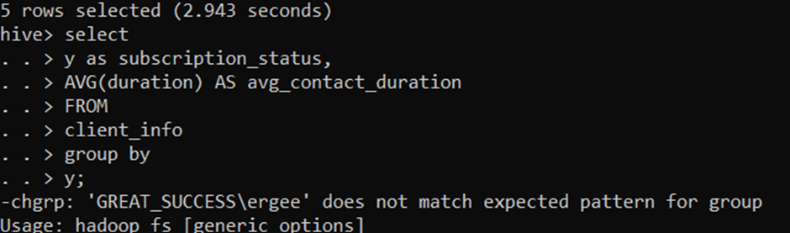

Result:

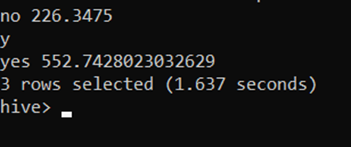

Summary of the Results:

subscription_status: Identifies whether the client subscribed to the term deposit (yes or no)

avg_contact_duration: Displays the average time spent contacting clients, differentiated by their subscription outcome.

This analysis reveals if contact duration plays a role in client decisions. A higher average duration among those who subscribed suggests that longer engagements might be more effective in leading to a successful subscription.

**Submission Guidelines:**

* Make a copy of this doc file.
* Perform the analysis in your local system using Hadoop and Hive and provide screenshots of both the **code** and the **output** under each question.
* Upload the doc file with other files and submit it in the submission dashboard.